**Statistical Analysis of ECG Signal for Myocardial Ischemia**

**B.Tech. Project Report-II**

By

**Name of the B.Tech. Students**

**Madhurima Purkait**

**Pratyusha Sinha**

**Subrata Sarkar**

**Sneha Tiwari**

**Under Supervision of**

**Mr. Bimal Pal**



**Department of Computer Sc. and Engineering**

**Government College of Engineering and Ceramic Technology**

**Kolkata**

**December 2021**

**Statistical Analysis of ECG Signal for Myocardial Ischemia**

**A Project Report**

*Submitted in partial fulfillment of the*

*requirements for the award of the degree*

***of***

**Bachelor of Technology**

**In**

**Computer Sc. and Engineering**

*By*

**NAME OF THE STUDENTS (with University Roll Number)**

**GCECTB-R17-3013**

**GCECTB-R17-3015**

**GCECTB-R17-3035**

**GCECTB-R17-3041**

## 

**Department of Computer Sc. and Engineering**

**Government College of Engineering and Ceramic Technology**

**Kolkata**

**July 2021**

**DECLARATION**

We hereby declare that the project entitled **“Statistical Analysis of ECG Signal for Myocardial Ischemia”** submitted for the B. Tech. (CSE) degree is our original work and the project has not formed the basis for the award of any other degree, diploma, fellowship or any other similar titles.

**Name and Roll No. of the Students Signature of the Students**

1.Madhurima Purkait(GCECTB-R17-3013) Madhurima Purkait

2.Pratyusha Sinha(GCECTB-R17-3015) Pratyusha Sinha

3.Subrata Sarkar(GCECTB-R17-3035) Subrata Sarkar

4.Sneha Tiwari(GCECTB-R17-3041) Sneha Tiwari

**Place: Kolkata**

**Date: 06/07/2021**

|  |  |
| --- | --- |
|  | **Government College of Engineering and Ceramic Technology**  **73, A. C. Banerjee Lane, Kolkata, West Bengal 700010** |

**…………………………………………………………………………**

**BONAFIDE CERTIFICATE**

Certified that this project report titled Statistical Analysis of ECG Signal for Myocardial Ischemia is the authentic work carried out by Madhurima Purkait, Pratyusha Sinha, Subrata Sarkar, Sneha Tiwari (GCECTB-R17-3013, GCECTB-R17-3015, GCECTB-R17-3035, GCECTB-R17-3041) who carried out the project work under my / our supervision. Certified further, that to the best of my knowledge the work reported herein does not form part of any other project report or dissertation on the basis of which a degree or award was conferred on an earlier occasion on this or any other candidate.

*…………………………………..*

**Mr.** **Bimal Pal**

**SUPERVISOR**

Assistant Professor

Department of Computer Science and Engineering

Government College of Engineering and

Ceramic Technology

Kolkata-700010

*…………………………………..* *…………………………………………*

**Dr. K. Saha Roy External Examiner**

**HEAD OF THE DEPARTMENT**

Assistant Professor & Head

Department of Computer Science and Engineering

Government College of Engineering and

Ceramic Technology

Kolkata-700010

**Abstract**

The Electrocardiogram (ECG), a noninvasive technique is use as a primary diagnostic tool for cardiovascular diseases. A cleaned ECG signal provides necessary information about the electrophysiology of the heart diseases and ischemic changes that may occur. It provides valuable information about the functional aspects of the heart and cardiovascular system. The objective of the project is to automatic detection of cardiac diseases from ECG signal. The aim of this work is to detect automatically myocardial ischemia automatically from raw ECG input for V4 lead. After having represented the ECG equivalent in time frequency domain, we detect the slope of the QRS complex and QRS angle. We use a one-dimensional convolutional neural network to detect any abnormality in the ECG waveforms. After training and testing our model, it will be able to detect Myocardial Ischemia. The method is tested on test set from European ST-T database from Physiobank database as well as on manually generated ECG wave.

**Acknowledgement**

We, Madhurima Purkait, Pratyusha Sinha, Subrata Sarkar, Sneha Tiwari (GCECTB-R17-3013, GCECTB-R17-3015, GCECTB-R17-3035, GCECTB-R17-3041) of CSE department 2017-2021 batch, want to acknowledge some precious gems who have contributed greatly in the completion of this project.

First of all, I thank Mr. Bimal Pal (our guide for this project) for his able guidance and motivation. Next, we thank all the group members for helping each other out. We would also like to thank our parents and friends for giving us advises. Finally, we want to thank the All-Mighty God for giving us an opportunity to indulge in such a monumental work.

**List of Figures**

|  |  |
| --- | --- |
| Figure no | Figure Name |
| Figure 1 | Various ECG waves |
| Figure 2 | Anatomy of Human Heart |
| Figure 3 | A normal ECG signal |
| Figure 4 | Various ECGs for Myocardial Infraction |
| Figure 5 | Custom 5-layer CNN Model |
| Figure 6 | R peak Detection |
| Figure 7 | Detecting QRS point |
| Figure 8 | Train Data CSV Sample |
| Figure 9 | Recorded QRS angle |
| Figure 10 | Training our Model |
| Figure 11,17 | Training and Validation Loss graph |
| Figure 12,18 | Training and Validation Accuracy Graph |
| Figure 13,19 | Confusion Matrix |
| Figure 14,20 | Sample ECG input |
| Figure 15 | Result for custom manual input |
| Figure 16 | QRS point highlight |

**Table of Contents**

|  |  |  |
| --- | --- | --- |
|  |  |  |
|  | Title Page | i |
|  | Declaration of the Students | iii |
|  | Bonafide Certificate | iv |
|  | Abstract | v |
|  | Acknowledgement | vi |
|  | List of Figures | vii |
|  | List of Tables | viii |
|  |  |  |
|  |  |  |
| **1.** | **INTRODUCTION** | **1** |
|  | * 1. Problem Definition   2. Project Overview/Specifications   3. Software and Hardware Specification | 1  1  2 |
|  |  |  |
| **2.** | **LITERATURE SURVEY** | **3** |
|  | 2.1 Details about myocardial ischemia, ECG and human heart  2.2 Existing System  2.3 Proposed System | 3  7  7 |
|  |  |  |
| **3.** | **SYSTEM ANALYSIS & DESIGN** | **8** |
|  | 3.1 Requirement Specification  3.2 CNN Model diagram  3.3 Design and Test Steps / Criteria  3.3 Algorithms and Pseudo Code  3.4 Testing Process | 8  9  9  13  14 |
|  |  |  |
| **4.** | **RESULTS / OUTPUTS** (should focus on **Results and Discussion/Analysis)** | **17** |
|  |  |  |
| **5.** | **CONCLUSIONS AND SCOPE FOR FUTURE WORK** | **20** |
| **6.** | **REFERENCES** | **21** |

**Introduction**

1.1 **Problem Definition**

Myocardial ischaemia occurs when blood flow through one or more coronary arteries decreases which in turn reduces the amount of oxygen received by the heart and can slowly overtime lead to serious complications. It requires review of an ECG by highly trained specialists and confirmation through clinical history, vital signs and laboratory exams. Myocardial ischaemia usually manifests as an area of ST segment depression or T wave flattening or inversion [1] on ECG record. In addition, clinicians are faced with reading high volumes of ECGs every shift.

1.2 **Project Overview**

The Physionet is a repository of freely available medical research data and we have used the European st-t dataset (namely records e0103, e0104, e0105, e0108) provided by them for training our model.[2] Even though technology has made progress this far, still people have no way to use the available technology to increase their quality of life. So, we created this CNN which can predict myocardial ischaemia with approximately over 90 % accuracy. This will enable technicians to increase their efficiency and allow patients to consult with a physician immediately if disease detection gives positive result. We have trained our model on a limited dataset and we need to increase the input data along with variations possible in input data. Myocardial ischaemia mainly characterized by ST segment depression and T wave flattening or inversion.

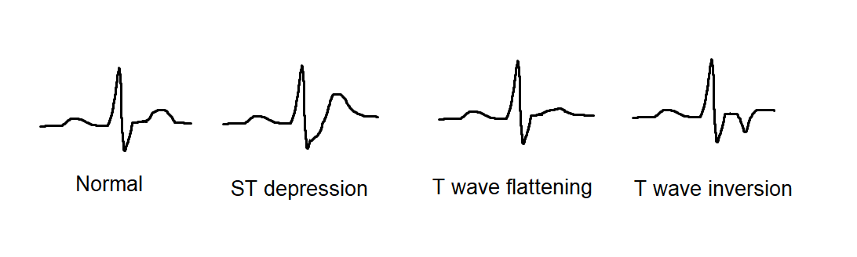

Figure 1: Various ECG waves

While there are numerous conditions that may simulate myocardial ischaemia (e.g., left ventricular hypertrophy, digoxin effect), dynamic ST segment and T wave changes (i.e., different from baseline ECG or changing over time) are strongly suggestive of myocardial ischaemia.[1]

1.3 **Software and Hardware specification**

We have used Keras with Tensorflow backend to create our convolutional neural network. We then used open source ECG data available on Physionet to train our deep learning model. We have tried our best to build a model that is light weight but provides acceptable accuracy with high specificity so that it can deployed and used on everyday computation devices or can be handled by less powerful computers easily.

**Literature Survey**

2.1 **Details about myocardial ischemia, ECG and human heart**

The Myocardial ischemia occurs because of insufficient oxygen supply to the heart, leading to ischemic heart disease (IHD). It is the leading cause of death worldwide, responsible for more than 8 million deaths globally every year (World Health Organization, 2016). If untreated, ischemia can lead to a myocardial infarction (MI), commonly known as a heart attack. MI causes cell death and can lead to permanent damage to the heart muscle if not treated immediately. In many cases early signs of ischemia are overlooked or ignored by the patient. Timely detection and treatment of IHD can stop progression towards MI and save many lives and prevent permanent damage to heart muscle. Thus, the aim is to develop an algorithm to detect ischemic events in ambulatory ECG signals. This can be used for continuous monitoring of a suspected ischemic patient and provide early detection of myocardial ischemia.

*Human Heart:*

The human heart is an organ that pumps blood throughout the body via the circulatory system, supplying oxygen and nutrients to the tissues and removing carbon dioxide and other wastes.

Blood delivers oxygen and nutrients to every cell and removes the carbon dioxide and other waste products made by those cells.

Blood is carried from the heart to the rest of the body through a complex network of arteries, arterioles and capillaries. Blood is returned to the heart through venules and veins.

*The Heart Anatomy:*

The heart is made up of four chambers: two upper chambers known as the left atrium and right atrium and two lower chambers called the left and right ventricles.

It is also made up of four valves: the tricuspid, pulmonary, mitral and aortic valves.

The right atrium receives non-oxygenated blood from the body’s largest veins — superior vena cava and inferior vena cava — and pumps it through the tricuspid valve to the right ventricle.

The right ventricle pumps the blood through the pulmonary valve to the lungs, where it becomes oxygenated.

The left atrium receives oxygenated blood from the lungs and pumps it through the mitral valve to the left ventricle.

The left ventricle pumps oxygen-rich blood through the aortic valve to the aorta and the rest of the body.

The coronary arteries run along the surface of the heart and provide oxygen-rich blood to the heart muscle.

A web of nerve tissue also runs through the heart, conducting the complex signals that govern contraction and relaxation. A sac known as the pericardium surrounds the heart.

The outer layer of the pericardium surrounds the roots of the heart’s major blood vessels, and the inner layer is attached to the heart muscle.

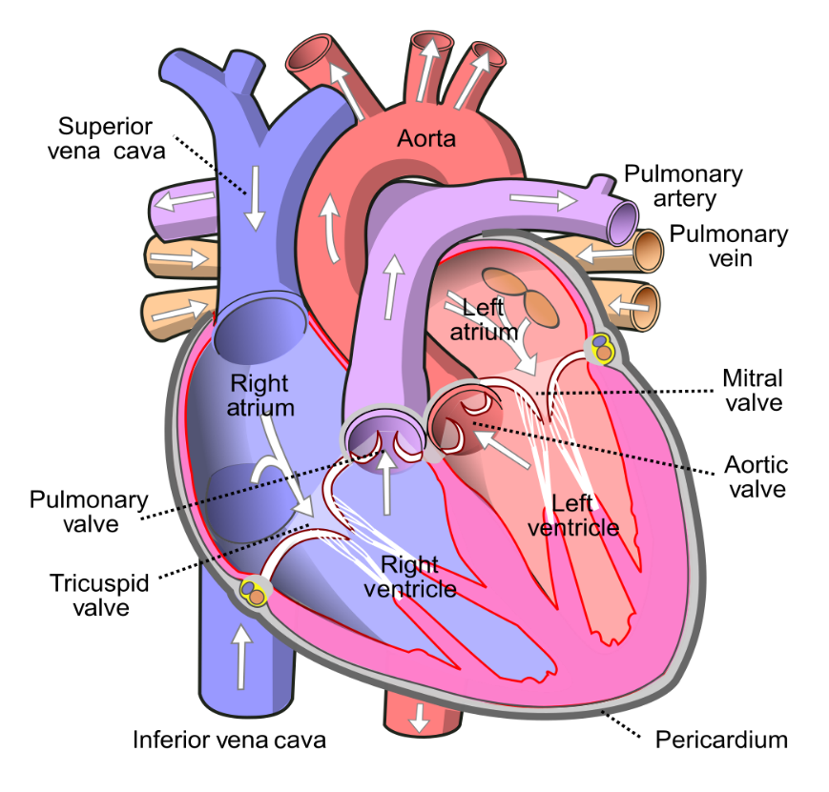

Figure 2:Anatomy of Human heart

Electrocardiogram (ECG):

It’s a non-invasive method of measuring the heart’s electrical activity during the cardiac cycle.

Electrocardiography is the process of producing an electrocardiogram (ECG or EKG). It is a graph of [voltage](https://en.wikipedia.org/wiki/Voltage) versus time of the electrical activity of the [heart](https://en.wikipedia.org/wiki/Heart" \o "Heart) using [electrodes](https://en.wikipedia.org/wiki/Electrode" \o "Electrode) placed on the skin. These electrodes detect the small electrical changes that are a consequence of cardiac muscle [depolarization](https://en.wikipedia.org/wiki/Depolarization" \o "Depolarization) followed by [repolarization](https://en.wikipedia.org/wiki/Repolarization" \o "Repolarization) during each cardiac cycle (heartbeat). Changes in the normal ECG pattern occur in numerous cardiac abnormalities, including cardiac rhythm disturbances (such as [atrial fibrillation](https://en.wikipedia.org/wiki/Atrial_fibrillation" \o "Atrial fibrillation) and [ventricular tachycardia](https://en.wikipedia.org/wiki/Ventricular_tachycardia" \o "Ventricular tachycardia)), inadequate coronary artery blood flow (such as [myocardial ischemia](https://en.wikipedia.org/wiki/Myocardial_ischemia" \o "Myocardial ischemia) and [myocardial infarction](https://en.wikipedia.org/wiki/Myocardial_infarction" \o "Myocardial infarction)), and electrolyte disturbances (such as [hypokalemia](https://en.wikipedia.org/wiki/Hypokalemia" \o "Hypokalemia) and hyperkalaemia).

What does an ECG measure?

A single round of the cardiac cycle shows up in 3 main “waves” on an ECG—the P wave, the QRS complex, and the T wave. These waves reflect the activities of the heart’s electrical conduction system, which is composed of specialized muscle fibres.

P-wave:  
A heartbeat starts with the generation of an electrical signal at the sinoatrial node (SA node)—the heart’s natural pacemaker—and that signal subsequently passes to the atrioventricular node (AV node). On an ECG, this is what the P wave, that first little blip, represents. The electrical signal that begins at the SA node and travels to the AV node stimulates the atria of the heart to contract, pushing blood into the ventricles.

PR Interval:  
The PR interval is the time between the start of the P wave and the start (the first deflection) of the QRS complex.

QRS wave complex:  
The big spike in the middle of the ECG is the QRS complex, which reflects the electrical signals leading to ventricular contraction. It’s made up of multiple waves, but they’re usually grouped together for analysis.

Once the electrical signal reaches the AV node, it passes on to the atrioventricular bundle (bundle of His), and then it travels down the bundle fibers to the Purkinje fibers. This stimulates the contraction of the ventricles, pushing blood out of the heart through the pulmonary artery and aorta.

ST Interval:  
The ST interval, or ST segment, is the time between the end of the QRS complex and the start of the T wave. This means it represents “[the period of zero potential between ventricular depolarization and repolarization](https://www.ncbi.nlm.nih.gov/books/NBK2214/)”.

T wave:  
The T wave represents the heart’s electrical activity returning to baseline—ventricular repolarization. (Atrial repolarization occurs during the QRS complex, so it isn’t clearly visible on the ECG readout.) After ventricular repolarization, the muscles of the ventricles relax.

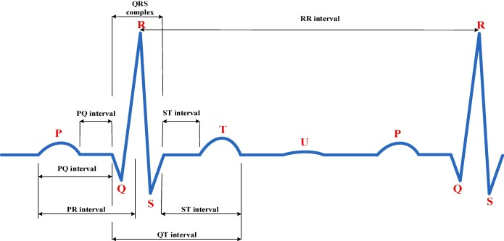

Figure 3:A Normal ECG Signal

12 Lead ECG:

The standard ECG has 12 leads. Six of the leads are considered “limb leads” because they are placed on the arms and/or legs of the individual. The other six leads are considered “precordial leads” because they are placed on the torso (precordium).

The six limb leads are called lead I, II, III, aVL, aVR and aVF. The letter “a” stands for “augmented,” as these leads are calculated as a combination of leads I, II and III.

The six precordial leads are called leads V1, V2, V3, V4, V5 and V6.

In Myocardial Infraction changes in ECG are:

1.ST segment elevation

2.T wave inversion

3.Appearance of wide deep Q waves.

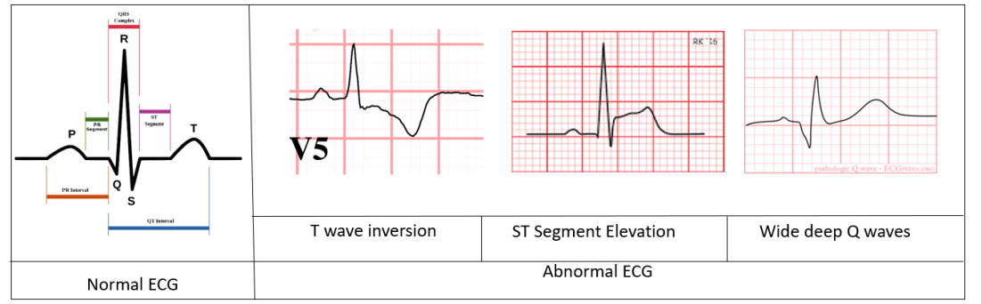

Figure 4:Various ECG for myocardial infraction

2.2 **Existing system**

There have been recent efforts on creating openly available ECG record databases with the studied patient numbers ranging from a few ten to one hundred. We have used ECG records provided by CNR Institute for Clinical Physiology in Pisa[3] on Physionet. “Multiclass classification of myocardial infarction with convolutional and recurrent neural networks for portable ECG devices” a paper published on ScienceDirect states how using images of ECG waves they are able to predict myocardial infraction.[4]

2.3 **Proposed system**

With the recent strides in the field of deep learning with visualization of CNN using activation maximization and other techniques it is easier to evaluate and properly understand the inner workings of the neural networks. But we feel using images as input can result in input data loss and also introduces variations in input data as we feed an image. So, we feed the ECG signal directly to our model and as a result believe to see large improvement in terms of classifying accuracy as we already know CNNs specialize in identifying hidden patterns in data and classifying data pretty accurately.

**System Analysis & Design**

3.1 **Requirement Specification**

Any Operating system with upgraded version of python 3.6.5 software.

Tensorflow -gpu -: 1.13.2-It is an open-source artificial intelligence library, using data flow graphs to build models. It allows developers to create large-scale neural networks with many layers. TensorFlow is mainly used for: Classification, Perception, Understanding, Discovering, Prediction and Creation.

Keras 2.3.1-: Keras is the python Deep learning library. It is an open-source software library that provides a Python interface for artificial neural networks. Keras acts as an interface for the TensorFlow library.

Wfdb 3.0.1-: The native Python waveform-database (WFDB) package. A library of tools for reading, writing, and processing WFDB signals and annotations.

Data requirements:

We used the European-st-t database which was intended to be used for evaluation of algorithms for analysis of ST and T- wave changes. This database consists of 90 annotated excerpts of ambulatory ECG recordings from 79 subjects.

And we as a group of 4 have used 4 databases (e0103, 10104, e0105 and e0108) respectively i.e., the ECG record of Four patient as our training and test dataset for the execution of the code.

In each data set we run a code where the dataset is divided into segments having 240 data point each (a typical heart rate has 70 to 75 beats per minute, i.e., each cardiac cycle takes about 0.8 seconds to complete the cycle).

3.2 **CNN model diagram**

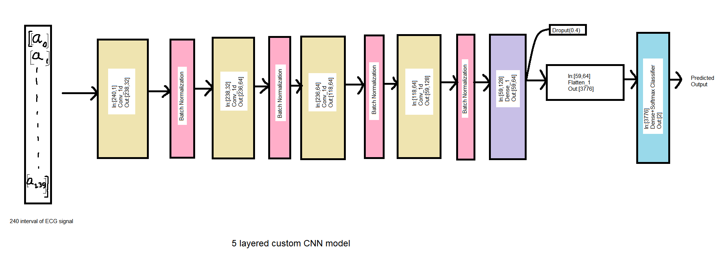

Figure 5:Custom 5-layer model

3.3 **Design and test steps**

At first, we plotted the ECG signals to see their pattern.

Next, we used XQRS detection to detect the R peaks in the ECG.

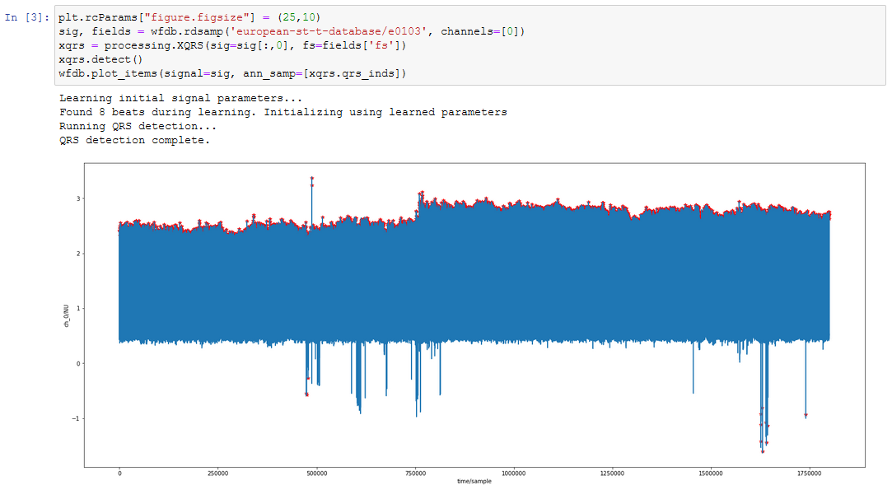

Figure 6: Detecting R peak

Next we sliced the first 250 points from the ECG recording and tried to locate the Q and S points from the change in slope the wave.

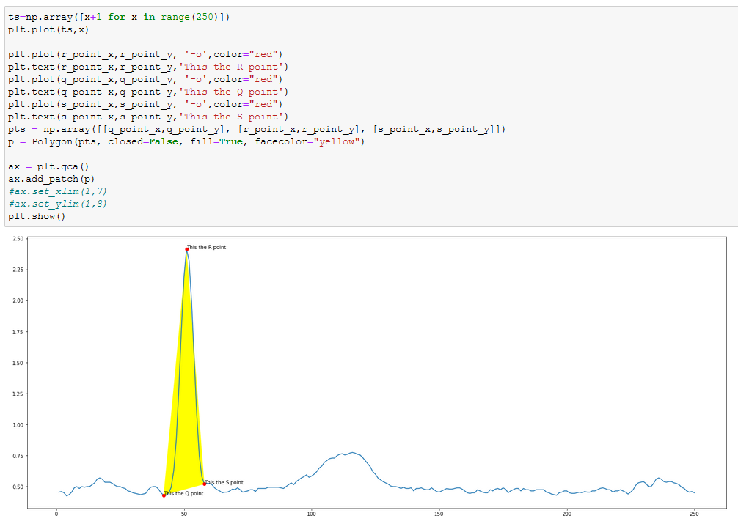

Figure 7: Detecting QRS points

We checked the duration of an average heartbeat which is 0.8 and then we calculated the number of samples that would make a heartbeat in ECG recording of st-t dataset which turned out to be 200 samples for 250 Hz recording rate. We took 40 samples as buffer and then sliced the dataset for every 240 units of data. And labeled this slice for myocardial ischaemia. For this we used a script which sliced and showed us ECG plot and we entered the label for the recording.



Figure 8: Train data csv sample

We also record the QRS angles for the ECG slices

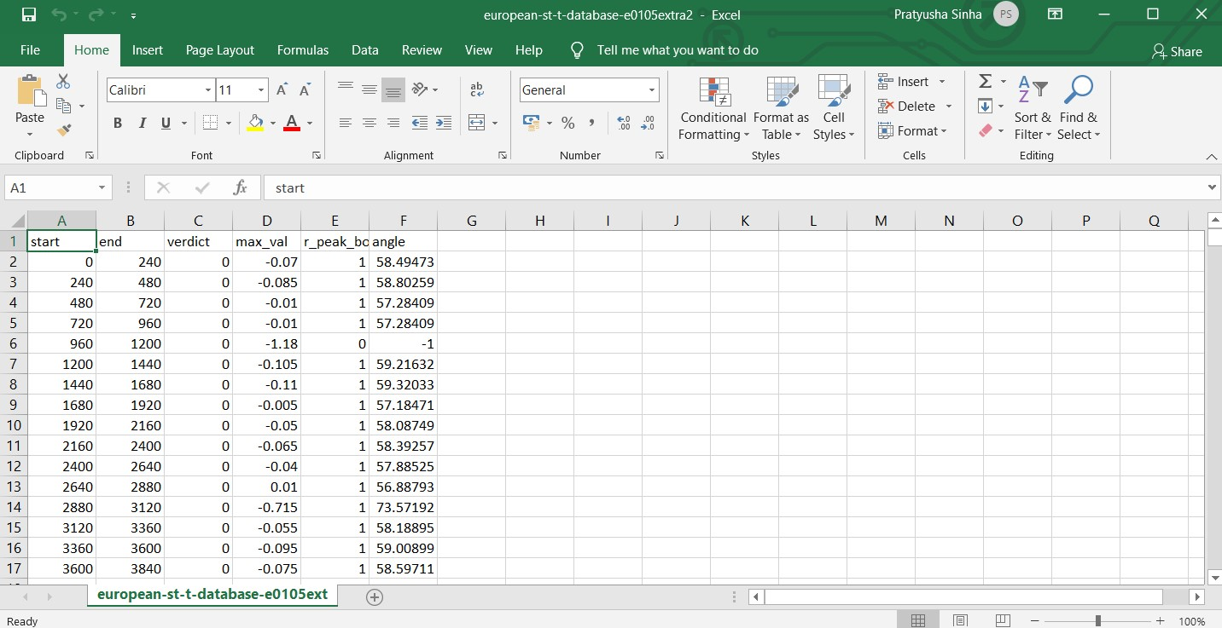

Figure 9: Recorded QRS angles

Next, we processed our data to be fed into our CNN model for training.

We do a split of train: validation: test data as 70:10:20

So, we have our train and test dataset now.

Creating our CNN model.

Training our model using a GTX 1660.

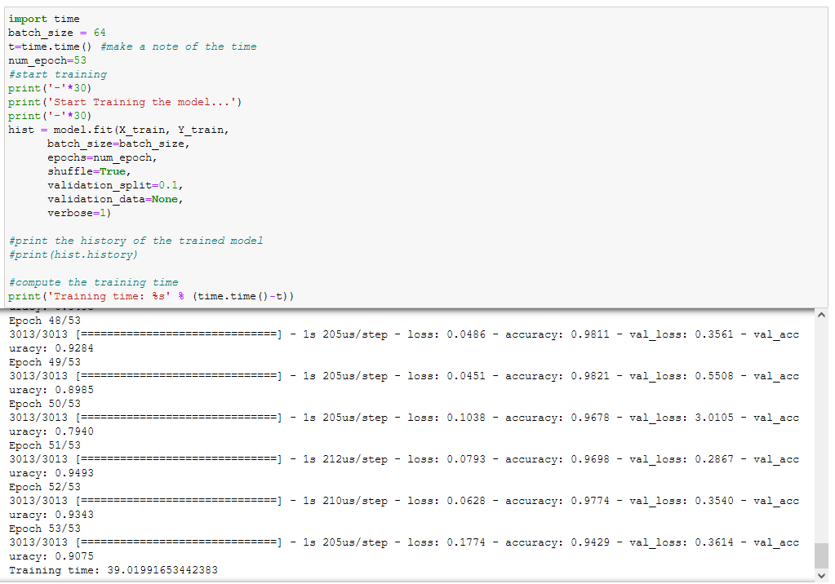

Figure 10: Training our model

Plotting the graphs for training accuracy and loss.

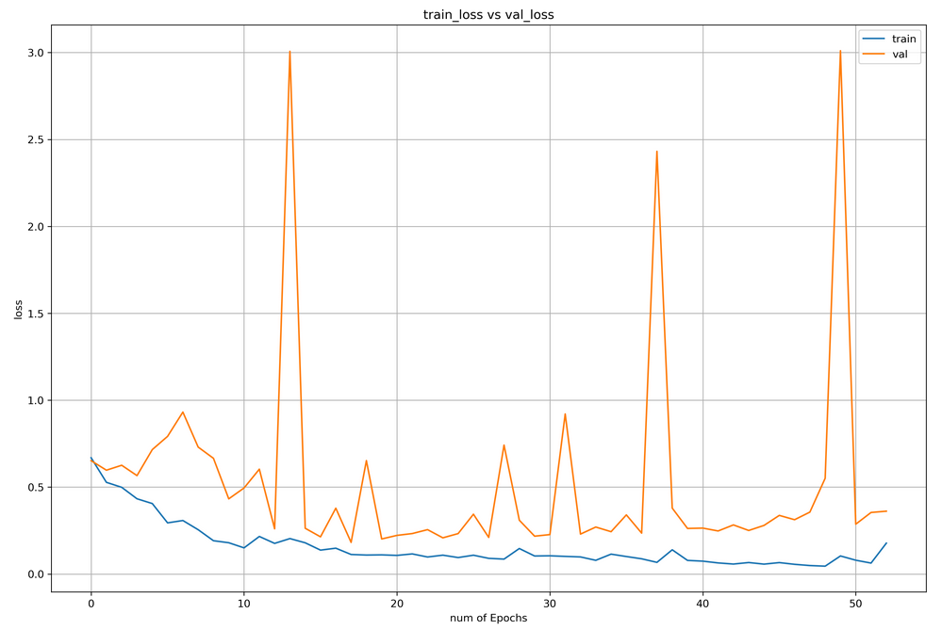

Figure 11: Training and validation loss graph

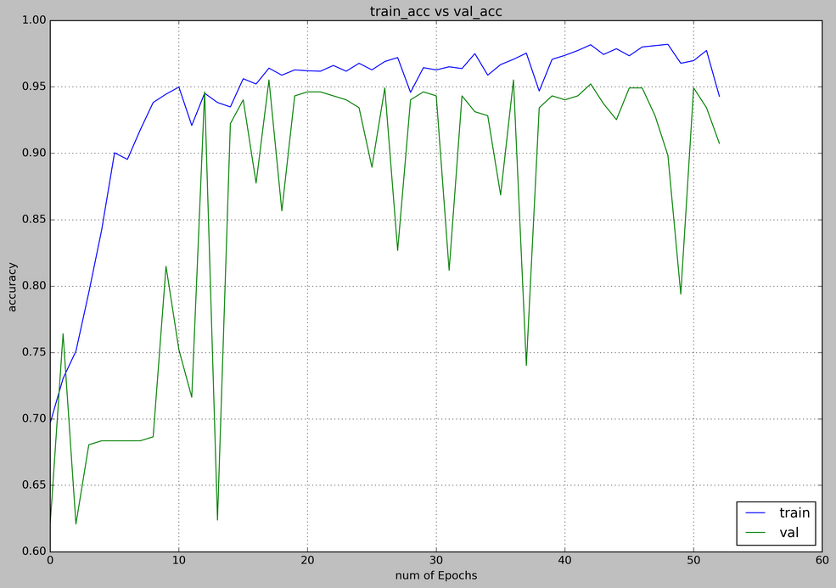

Figure 12: Training and validation accuracy graph

3.3 **Algorithm and pseudo-code**

Algorithm for Q point detection

1. Start
2. Use XQRS algo to detect r peak
3. From r peak go on moving left until value stops decreasing and starts increasing
4. Mark this point as Q
5. Return the point
6. Stop

Algorithm for S point detection

1. Start
2. Use XQRS algo to detect r peak
3. From r peak go on moving right until value stops decreasing and starts increasing
4. Mark this point as S
5. Return the point
6. Stop

3.4 **Testing process**

Testing our model on test data.

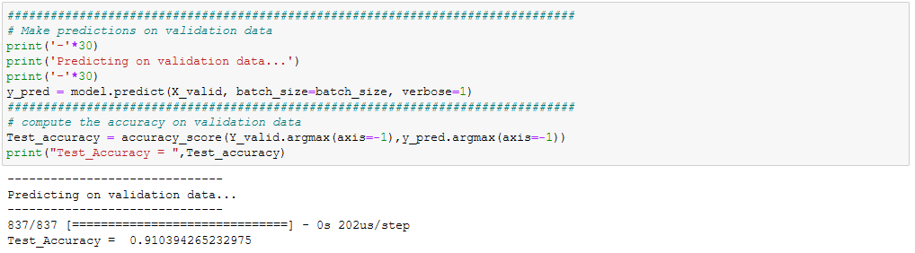

And now plotting the confusion matrix.

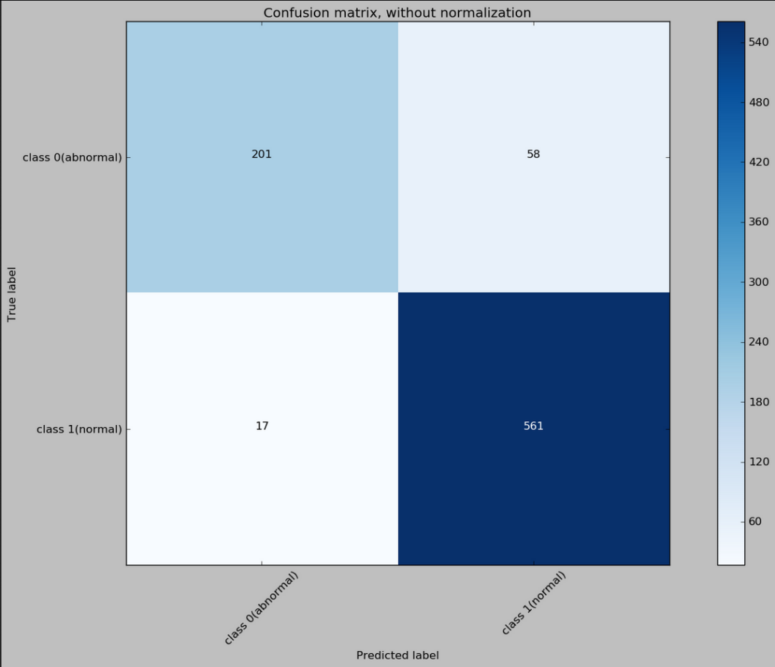

Figure 13: Confusion matrix

Now we create a script to take input and perform prediction on it.

First we load the model from the disk.

Next we take in custom input.

We take in 240 values.

x_new = [[-1.56 ], [-1.54 ], [-1.525], [-1.5 ], [-1.5 ], [-1.5 ], [-1.51 ], [-1.53 ], [-1.545], [-1.545], [-1.545], [-1.55 ], [-1.585], [-1.58 ], [-1.595], [-1.605], [-1.62 ], [-1.625], [-1.62 ], [-1.62 ], [-1.61 ], [-1.615], [-1.62 ], [-1.605], [-1.605], [-1.595], [-1.59 ], [-1.585], [-1.595], [-1.63 ], [-1.715], [-1.705], [-1.58 ], [-1.37 ], [-0.965], [-0.57 ], [-0.405], [-0.405], [-0.46 ], [-0.54 ], [-0.73 ], [-1.055], [-1.335], [-1.55 ], [-1.62 ], [-1.615], [-1.59 ], [-1.545], [-1.55 ], [-1.56 ], [-1.57 ], [-1.575], [-1.57 ], [-1.565], [-1.58 ], [-1.57 ], [-1.565], [-1.57 ], [-1.565], [-1.56 ], [-1.555], [-1.555], [-1.56 ], [-1.545], [-1.53 ], [-1.53 ], [-1.53 ], [-1.525], [-1.508], [-1.507], [-1.506], [-1.505], [-1.5 ], [-1.475], [-1.465], [-1.47 ], [-1.465], [-1.45 ], [-1.44 ], [-1.435], [-1.415], [-1.415], [-1.415], [-1.41 ], [-1.395], [-1.395], [-1.395], [-1.39 ], [-1.385], [-1.365], [-1.38 ], [-1.39 ], [-1.39 ], [-1.385], [-1.39 ], [-1.4 ], [-1.4 ], [-1.405], [-1.405], [-1.42 ], [-1.415], [-1.415], [-1.41 ], [-1.405], [-1.405], [-1.39 ], [-1.41 ], [-1.42 ], [-1.44 ], [-1.435], [-1.445], [-1.45 ], [-1.465], [-1.475], [-1.485], [-1.49 ], [-1.5 ], [-1.5 ], [-1.51 ], [-1.525], [-1.53 ], [-1.54 ], [-1.535], [-1.54 ], [-1.555], [-1.56 ], [-1.555], [-1.56 ], [-1.56 ], [-1.56 ], [-1.55 ], [-1.56 ], [-1.56 ], [-1.56 ], [-1.55 ], [-1.55 ], [-1.545], [-1.56 ], [-1.545], [-1.545], [-1.54 ], [-1.545], [-1.54 ], [-1.54 ], [-1.54 ], [-1.53 ], [-1.53 ], [-1.53 ], [-1.515], [-1.52 ], [-1.525], [-1.53 ], [-1.525], [-1.53 ], [-1.525], [-1.53 ], [-1.53 ], [-1.53 ], [-1.53 ], [-1.53 ], [-1.53 ], [-1.53 ], [-1.54 ], [-1.53 ], [-1.56 ], [-1.54 ], [-1.545], [-1.56 ], [-1.555], [-1.545], [-1.56 ], [-1.56 ], [-1.545], [-1.545], [-1.545], [-1.56 ], [-1.555], [-1.56 ], [-1.56 ], [-1.56 ], [-1.555], [-1.56 ], [-1.575], [-1.565], [-1.565], [-1.56 ], [-1.565], [-1.57 ], [-1.575], [-1.56 ], [-1.55 ], [-1.56 ], [-1.55 ], [-1.535], [-1.53 ], [-1.53 ], [-1.525], [-1.51 ], [-1.49 ], [-1.475], [-1.465], [-1.46 ], [-1.48 ], [-1.51 ], [-1.53 ], [-1.525], [-1.53 ], [-1.55 ], [-1.545], [-1.56 ], [-1.575], [-1.59 ], [-1.59 ], [-1.59 ], [-1.595], [-1.59 ], [-1.59 ], [-1.59 ], [-1.585], [-1.575], [-1.575], [-1.575], [-1.565], [-1.575], [-1.595], [-1.675], [-1.715], [-1.6 ], [-1.405], [-1.04 ], [-0.59 ], [-0.375], [-0.355], [-0.395], [-0.455], [-0.555], [-0.83 ], [-1.155], [-1.425], [-1.58 ]]

Plot the input just to show the user the ECG.

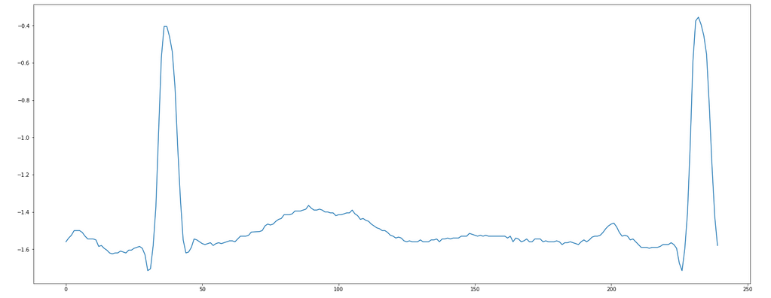

Figure 14: Sample ECG input

Then we perform the prediction. In this example we do it on a known ECG wave.

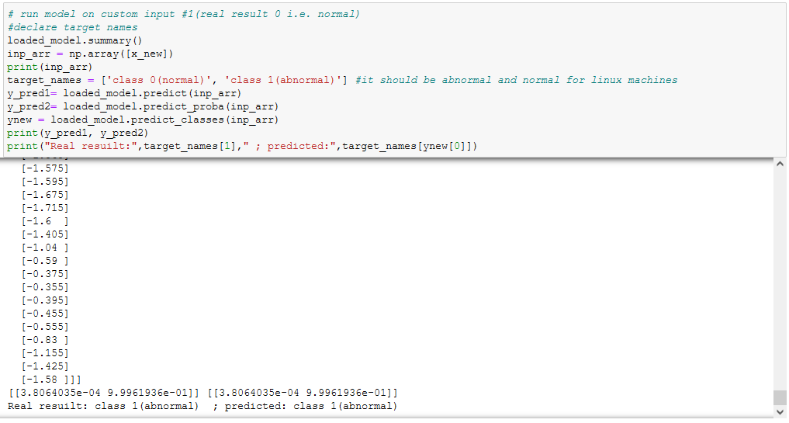

Figure 15: Result for custom manual input

We also check the angle made by the R peak in the wave and plot it.

We get the angle as 69.55 degree

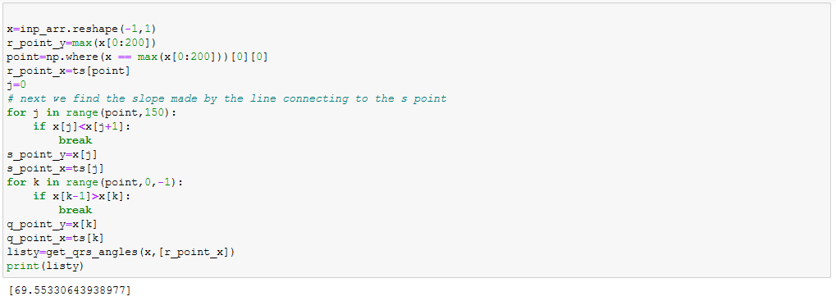

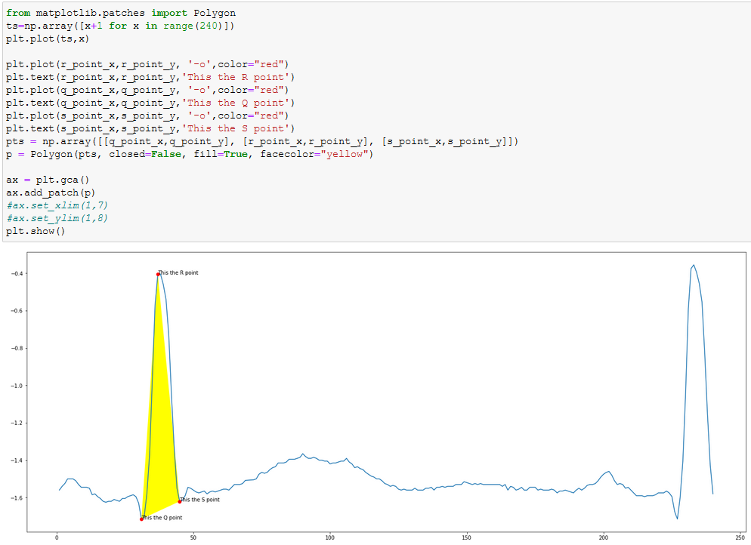

Figure 16: QRS point highlight

**Results and Discussion**

The Results for myocardial ischaemia detection:

Here we provide the table for comparison of the models:

|  |  |  |  |  |  |
| --- | --- | --- | --- | --- | --- |
| Models | Accuracy | Sensitivity | Specificity | F1-score | MCC |
| Custom model 5 layers | 0.9104 | 0.7761 | 0.9706 | 0.8428 | 0.7864 |

Table 1: Model metrics

Next we provide the metrics for training the models and also metrics on how the models performed on test data.

For training our model we followed the below mentioned approach:

The 5 layered model has been trained for 53 epochs .

Raw ECG signal was fed alongwith the classification.

The dataset is really small and more data is needed so that the model can account for variations such as brachardyia and trachardyia.

Custom model 5 layers:



Figure 17: Train and Validation loss graph



Figure 18: Train and Validation accuracy graph

Test_Accuracy = 0.910394265232975

Confusion matrix, without normalization:

[[201 58]

[ 17 561]]



Figure 19: Confusion matrix

Example of sample run on manually generated ECG with defects:

Sample input:



Figure 20: Sample ECG input

Real category: class 1(abnormal)

Predicted: class 1(abnormal)

**Conclusion and Scope for Future Work**

From the results we can conclude that the both CNN model described here performs pretty well. Also, the metrics for the test dataset prove the CNN model to be quite effective for ECG classification but more data is needed for training. The custom model has been tested for deployment using Flask locally. We hope this work will pave path for faster and efficient detection of myocardial ischaemia by the lab technicians and as a result help in faster diagnosis of patients. The model shows promising result.

**References**

1.https://litfl.com/myocardial-ischaemia-ecg-library/

2.https://physionet.org/content/edb/1.0.0/

3.https://www.cnr.it/en

4.Hin Wai lui, King Lau Chow, “Multiclass classification of myocardial infarction with convolutional and recurrent neural networks for portable ECG devices” available online at https://www.sciencedirect.com/science/article/pii/S2352914818301333l.